PR Weekly Report for 2/15 -2/21

# Flyer/Poster

We have finalized a poster design for this show. We will be doing a parody of the Xman Days of Future past poster as shown below. Ann is pulling some mock ups of the background and Mandy will do the cartoon characters of Freddie and Christine. This is the poster we are mocking:

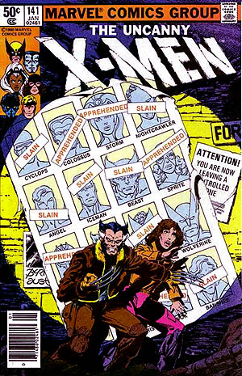

# Fundraisers

We have decided to move the Stuck on Soda fundraiser to march shortly after the break. Then we will do a second fundraiser closer to the show that will probably involve food and will actually focus more on the advertising of the show then the fundraiser itself.

# Task List

Lastly this week I am finalizing the task list and shirt it with the team on Slack. Its mostly in compensates a crossover of last list and this year’s new tasks. Message me on slack if you have anything that you think should be on there.